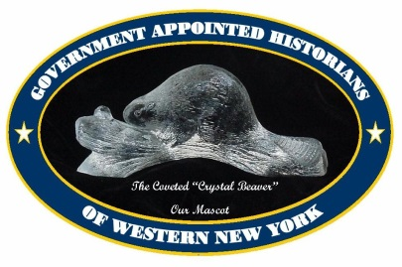 Government Appointed Historians of Western New York

Saturday, September 24, 2016

8:30 A.M. – 3:00 P.M.

United Methodist Church

Rt 63, Geneseo, New York 14454

**Program Agenda**

**8:30 A.M. Registrationand Refreshments**

**9:00 A.M. Welcome**

**9:15 A.M. GAHWNY Business Meeting: Election of Executive Board**

**10:00 A.M. Break**

**10:15 A. M. Homeless female veterans find shelter and support at the Zion House** -

**Speaker: Rev. Kelly Ayer, Zion House Director.** Zion House, located in Avon, Livingston County, is one of the first houses for female veterans in the country and the first in New York State. The home operates as a self-managed system and provides access to VA, community based services, and life-skills training. To support the house the women make a line of goat’s milk products. The Rev. Ayer, an Episcopal priest and retired Army veteran, will talk about the history of this unique place in our community.

**11:00 A.M**. **The history of the Geneseo Migrant Center: the oldest in the U.S.**

**Speaker: Robert Lynch, Retired Director of the BOCES Geneseo Migrant Center**

Dr. Gloria Mattera, founded the Geneseo Migrant Center in 1968 to serve the needs of farmworkers and their families. Since that time the center has expanded and received accolades for its efforts to provide educational, health, arts, and other program activities for thousands of adults and children in the immediate service area and also on a statewide, regional and national level. Bob Lynch will bring us a behind the scenes view of the migrant families and how this program has significantly improved their overall quality of life.

**11:45 A.M** **Presentation of the Julia Reinstein Award**

**Noon Lunch – Guest Speaker: *Devin Lander, the newly appointed State Historian, will***

***give us an update on his new role and listen to issues facing historians.***

**1:15 P.M.** **Launch of the new Documentary Heritage & Preservation Services Program -**

**Speaker: John Diefenderfer, Archivist, Archival Advisory Services, NYS Archives.** The New York State Education Department has awarded a five-year contract to the Conservation Center for Art and Historic Artifacts (CCAHA) to provide statewide archival and preservation services for eligible archives, libraries, historical societies, museums, and other institutions that hold historical records and/or library research materials. John Diefenderfer will explain the roll out of this program and other services targeted to the historical records community.

**2:00 P.M. Break**

**2:15** P.M. ***He’s been working on the railroad all the live long day****:* doing railroad research - **Speaker: Michael Connor, retired railroad executive and current President of the Erie Lackawanna Historical Society.** Michael Connor has held numerous high-level positions on the major rail lines in the Northeast including Penn Central, Conrail, Chicago, Central & Pacific, the Ohio Central, the Livonia, Avon & Lakeville/Western New York & Pennsylvania. He is the fourth generation in his family to serve the Erie or the Erie Lackawanna Railroads. His personal goal is to see that their stories are made available to those who didn’t have the privilege of knowing these railroads first-hand.

**3:00 P.M. Meeting wrap up. *Optional tour of the National Warplane Museum.***